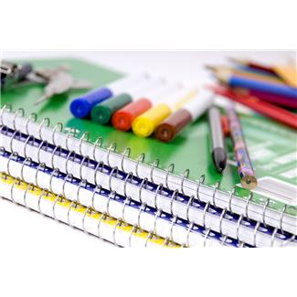
Mr. Wells & Mrs. McCann’s 2013-14 School Supply List

Dear Parents,
Thank you for providing the necessary materials to ensure your fifth grade student is prepared and ready to succeed this school year. Below is a list of supplies that will make your child’s journey in 5th grade a success. If, for any reason, you cannot provide the supplies listed below, please contact me and I will gladly ensure that the supplies are provided on the first day of school.
Sincerely,
Mrs. McCann
Mr. Wells
Student Supplies
Notebook Paper (Daily supply)
Pencils (Daily supply)
Scissors
Colored Pencils
Pack of Expo markers (4 pack please)
Zippered canvas or cloth pencil bag (not a box)
1 pack of glue sticks (large)
Container of Clorox wipes
2 boxes of tissues
1 box of Ziploc baggies (quart or gallon size)
1 two inch three ring binder
Hole reinforcers for notebook paper
1 pack of index cards
1 pack of Crayola markers
Pack of ball point pens (preferably blue, green, or red)
2 highlighters
1 handheld pencil sharpener
2 marble composition notebooks
1 pack of 5 notebook dividers

Please free to contact us if you any questions or concerns at jlwells@appomattox.k12.va.us or kdmccann@appomattox.k12.va.us.

