**Daily Schedule  
8:00- 8:25- S.M.I.L.E. Time**8:30-9:20- I/E  
  
9:2010:10- Resource

10:10-12:10- Academic Classes  
 *(see individual student schedule)*  
  
12:10-1:00- Lunch/Recess

*12:10-12:40- Hogan/Jamerson*

*12:15-12:45-Hix/McCann/Wells*

*1:00-3:00- Academic Classes   
(see individual student schedule)*

3:00-3:26- Dismissal/Homework Time

**Resource Schedule**

Monday- **Music**

Tuesday- **P.E.**

Wednesday- **Art**

Thursday- **Library**

Friday- **Compass Math**

**On P.E. days, please remember to wear tennis shoes.**



**Welcome to 5th Grade**

**Mrs. Hix- Reading & Writing**[ddhix@appomattox.k12.va.us](mailto:ddhix@appomattox.k12.va.us)

**Mrs. Hogan- Reading & Math**[dghogan@appomattox.k12.va.us](mailto:dghogan@appomattox.k12.va.us)

**Mrs. Jamerson- Science**  
[bcjamerson@appomattox.k12.va.us](mailto:bcjamerson@appomattox.k12.va.us)   
  
**Mrs. McCann- Writing**  
[kdmccann@appomattox.k12.va.us](mailto:kdmccann@appomattox.k12.va.us)   
  
**Mr. Wells- Math**

[jlwells@appomattox.k12.va.us](mailto:jlwells@appomattox.k12.va.us)   
  
  
[](http://www.google.com/url?sa=i&source=images&cd=&cad=rja&docid=H277kj0qMRbpwM&tbnid=a5tSQZofsIYSQM:&ved=0CAgQjRwwAA&url=http://school.discoveryeducation.com/clipart/clip/ani_thinkingcap.html&ei=PQQFUovwAqb7yAHxsIHwCA&psig=AFQjCNEhAuPez3PwJOcGTwAZjMVhc7hpZQ&ust=1376146877097440)

***“Brain Commander: Creating a Dynasty of learners for the 21st Century”***

***Appomattox Elementary***

***Phone: 352-7463***

Classroom Expectations

1. **A- Always Respect Others**
2. **E- Exercise self-control**
3. **S- Stay on Task**

**Behavior Management Plan**

1st: **Yellow Card**- Warning

2nd: **Orange Card**- Lose a ticket & loss of recess.

3rd: **Blue Card**- Student will write note home and/or call home. Letter must be signed and returned the next day for no further consequences.

4th: **Red Card**- Referral to the office.

Student Signature:

_____________________________

Parent Signature:

_____________________________

Date: _________________

**Helpful Information for Students & Parents**

Where can I find useful classroom information?  
  
Check out Mr. Wells’ website. [www.mrwells.weebly.com](http://www.mrwells.weebly.com)   
  
Check out our Team website on the Appomattox  
Elementary School website!

**Helpful Sites and Resources**

Go to <http://www.portaportal.com>

Guest Name: redskins

Guest Name: s105

Guest Name: kdmccann

**Grading Scale**

93-100- A

85-92- B

77-84- C  
70-76- D

Below a 70- F

**Helpful Reminders**

1. Spelling Tests are given on Fridays.

2. If your child has an immediate health problem, please let us know.

3. Students will receive Scholastic book orders once a month. Please check our newsletter for specific due dates.

4. A folder with your child’s graded papers will come home every other Monday. These folders are required to be signed and returned on Tuesday.

5. If your child is absent, please send in a note the next day explaining their absence.

6. Reading logs will be collected each Friday for a grade. On the back of the assignment, you will find how many points they have acquired and their percentage for their AR tests.

7. Please check out PowerSchool to see your child’s progress. If you do not have access, see Mrs. Chavis in the main office.

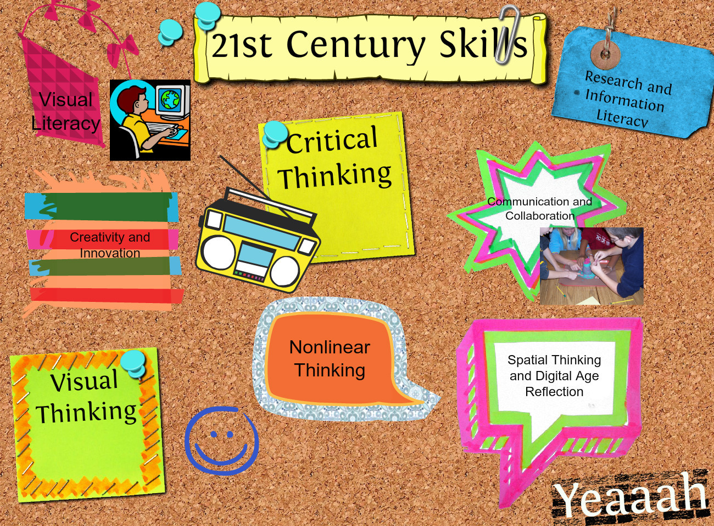

Homework

Homework will be graded in a variety of methods.

* Completion
* Accuracy

Students should complete their reading log each night. Periodically, students will have a project or homework in Science, Math, and Language Arts. Students will also be encouraged to study for tests and quizzes as part of their homework assignments!

*Students not turning in homework on time will lose recess and a ticket.

Make-up Policy

When students are absent, the procedure is:

1. Notes should be obtained from a fellow student.
2. **Students** should contact the teacher for missed assignments.
3. All missed work is to be completed. Please refer to student handbook.
4. Students missing class for ALPS, SCA, sports, etc. are responsible for completing and turning in assignments when they are due.